

# KOLEJ PROFESIONAL MARA BERANANG DIPLOMA IN COMPUTER SCIENCE

|  |  |  |
| --- | --- | --- |
| **COURSE NAME** | : | **OBJECT ORIENTED PROGRAMMING** |
| **COURSE CODE** | : | **CSC2744** |
| **ACADEMIC SESSION** | : | **SESSION 3 2024/2025** |
| **TYPE OF ASSESSMENT** | : | **FINAL ASSIGNMENT** |
| **DURATION** | : | **05/02/2025 - 03/03/2025** |

**CLO 3: Employ third party data in object oriented application development using graphical user interface (GUI) application framework**

**INSTRUCTION TO CANDIDATES:**

1. Late submissions after the given due date will not be accepted.
2. Report should be written using: Font type: Arial

Size: 12 pts

Line Spacing: 1.5

1. Coding format:

Font type: Consolas Size: 10 pts

Line Spacing: Single

|  |  |
| --- | --- |
| **Personal Details** | |
| **Name** | NUR SYAKIRAH BINTI ROZAINI |
| **I/D Number** | BCS2311-035 |
| **Class** | DCS4A |
| **Lecturer** | MDM NINI ANIZA BINTI ZAKARIA |

|  |  |
| --- | --- |
| **Section / Question No.** | **Marks** |
| 1 |  |
| 2 |  |
| 3 |  |
| 4 |  |
| 5 |  |
| 6 |  |
| **Total** | **/ 50** |

I hereby declare that no form of plagiarism will be tolerated in this assessment. Failure to comply will result in a failing grade for the assessment.

Signature: Date:

**Question**

In JavaScript development, **Electron** is a framework that allows developers to build cross-platform desktop applications using web technologies like HTML, CSS, and JavaScript. It wraps a web application (which would normally run in a browser) inside a desktop environment, enabling it to run as a native application on platforms like Windows, macOS, and Linux.

Many popular desktop applications, like Visual Studio Code, Slack, Discord, and Spotify (desktop version), are built using Electron. As part of your software development course, you have been tasked to develop a desktop application using Electron with web technologies like HTML, CSS, JavaScript and utilizes the third-party data from one of the given API. You also need to incorporate CRUD (Create, Read, Update, Delete) operations to enhance user interaction and usability.

|  |  |
| --- | --- |
| **Name of**  **Application** | **Key Features:** |
| Solah Tracker for Kids | * Help parents track their children’s daily prayers. * Display key information like 5 prayer times, day and hijri date. * User able to search prayer time by prayer zone * CRUD – Personal detail of child like name, age. Able to record daily 5 prayers and also sunnah prayers for each individual. <https://api.waktusolat.app/solat/SGR01> |
| Quran Journal | * Allow users to view list of surah in the Al-Quran, and note their spiritual discovery of every surah. * Display key information like surah name, surah number, English translation, number of ayahs and revelation type. * User able to search surah by surah name * CRUD – number of ayahs completed and notes for self-reflection. <http://api.alquran.cloud/v1/surah> |

|  |  |
| --- | --- |
| **Name of**  **Application** | **Key Features:** |
| Hadith Buddy | * Displays random hadith from Sahih Bukhari. Allows user to track favorite hadiths in list. * Display key information like hadith number, hadith in English, narrator, book source, hadith status, and hadith chapter. * Allows user to search hadith by book source. * CRUD – favorite hadiths by hadith number and personal reflection regarding hadiths. * [https://hadithapi.com/api/sahih-](https://hadithapi.com/api/sahih-bukhari/chapters?apiKey=%242y%2410%24imRVx8ZhnDdBGcKCABQ95ePS8VhQ6gFzUnWyIbR4xeYsGFDrGcnvC) [bukhari/chapters?apiKey=$2y$10$imRVx8ZhnDdBGcKCABQ95e](https://hadithapi.com/api/sahih-bukhari/chapters?apiKey=%242y%2410%24imRVx8ZhnDdBGcKCABQ95ePS8VhQ6gFzUnWyIbR4xeYsGFDrGcnvC) [PS8VhQ6gFzUnWyIbR4xeYsGFDrGcnvC](https://hadithapi.com/api/sahih-bukhari/chapters?apiKey=%242y%2410%24imRVx8ZhnDdBGcKCABQ95ePS8VhQ6gFzUnWyIbR4xeYsGFDrGcnvC) |
| Sunnah Meal | * Suggests menu based on sunnah food as ingredients. * Display key information like recipe title, image, missed ingredients, and used ingredients * CRUD – create meal plan for the week based on searched recipe. * [https://api.spoonacular.com/recipes/findByIngredients?apiKey=15](https://api.spoonacular.com/recipes/findByIngredients?apiKey=153ed267f6fe4cc1978d7d8576103378&ingredients=dates) [3ed267f6fe4cc1978d7d8576103378&ingredients=dates](https://api.spoonacular.com/recipes/findByIngredients?apiKey=153ed267f6fe4cc1978d7d8576103378&ingredients=dates) |

# Tasks:

1. Create desktop application using electron framework with the integration of the given API. Your application needs to output the information required above. It should have at least 2 pages, and you may add extra functionality or features of your choice to the application.
2. Implement CRUD (create, read, update, delete) process to the application to make your application more meaningful.
3. Apply HTML and CSS for user interface and provide evidence for application.
4. GUI Elements:
   1. Apply GUI elements that assist users in using applications.
   2. The application’s ‘look and feel’ is attractive and informative.
5. Produce a report on your application. Include the following:
6. Overview of the application and its purpose. Include explanation of the information retrieved from the given API and CRUD process.
7. Description of the functionalities and features of the developed application with print screen of the pages and explanation.
8. Program codes of your system
9. Submit files in GitHub and include the link in the report.

**Assessment Rubric**

|  |  |  |  |  |  |  |  |  |
| --- | --- | --- | --- | --- | --- | --- | --- | --- |
| **ATTRIBUTES** | **CRITERIA** | **POOR**  **(1 mark)** | **FAIR**  **(2 marks)** | **GOOD**  **(3 marks)** | **VERY GOOD**  **(4 marks)** | **EXCELLENT**  **(5 marks)** | **Weightage** | **Mark Obtained** |
| **Reproduce and Process Information** | 1. Create desktop application using electron framework with the integration of the given API. Your application needs to output the information required above. | * The application is an extensive collection and rehash of other people's ideas, products, and images. There is no evidence of new thought. | * The application is somewhat a collection and rehash of other people's ideas, products, and images. There is little evidence of new thought or inventiveness. | * The application is a minimal collection or rehash of other people's ideas, products, and images. There is a few evidence of new thought or inventiveness   . | * The application shows a lot of evidence of originality and inventiveness. | * The application shows significant evidence of originality and inventivenes s. * Most of the content and many of the ideas are fresh,original, and   inventive. | **1** |  |
| * Unable to display all the required data from the API and does not fulfill the requirements. | * Able to display all the required data from the API that meet with the requirements. | * Able to display extra data from the API beyond the application requirements. | * Able to display extra data from the API beyond the application requirements with the   description in the report |  | **1** |  |
| * The data from the API does not reflect the whole purpose of the application developed. | * The data from the API is sufficient but does not reflect the whole purpose of the application developed. | * The data from the API is meaningful but does not reflect the purpose of the application developed. | * Able to utilize the data fetched from the API to come up with meaningful functionalities that reflect the purpose of the application   developed. | * Able to utilize the data fetched from the API to come up with meaningful functionalitie s that reflect the purpose   of the |  |  |

|  |  |  |  |  |  |  |  |  |
| --- | --- | --- | --- | --- | --- | --- | --- | --- |
|  |  |  |  |  |  | application developed.   * Come up with extra idea for the application developed that enhances the user experience or adds   value to the application. |  |  |
| 2. Implement CRUD (create, read, update, delete) process to the application to make your application more meaningful. | * Able to create only 2 of the CRUD   processes.   * No feedback for the CRUD process. * The design for data input is poor | * Able to create only 3 of the CRUD   processes.   * No feedback for the CRUD process. * The design for data input is good with some room for improvement | * Able to perform all the CRUD   processes.   * No feedback for the CRUD process. * Well-designed data input for CRUD   process. | * Able to perform all the CRUD processes. * No feedback for the CRUD process. * Well-designed data input for CRUD process. | * Able to perform all the CRUD   processes.   * Appropriate feedback for the CRUD process. * Well-designed and user- friendly data input for CRUD   process. | **1** |  |
|  | 3. Apply HTML and CSS for user interface and provide evidence for application. | * **Text -** All text used is too small to view or the font type is wrongly chosen. * **Graphics** - Graphics seem randomly chosen, are of low quality, OR | * **Text** – Some of the text used is too small to view or the font type is wrongly chosen. * **Graphics -** Graphics seem randomly chosen, are of   low quality, | * **Text** - Most text used is clear but does not describe the content well. * **Graphics** - Graphics are related to the theme/purpos e of the application and are of | * **Text** - All text used is clear but does not describe the content well. * **Graphics -** Graphics are related to the theme/purpose of the application, are of | * **Text** - All text used is clear and able to describe the content well. * **Graphics** - Graphics are related to the theme/purpos e of the application, | **1** |  |

|  |  |  |  |  |  |  |  |  |
| --- | --- | --- | --- | --- | --- | --- | --- | --- |
|  |  | distract the reader. | OR distract the reader. | excellent quality. | excellent quality and enhance reader interest or understanding | are thoughtfully cropped, are of high quality and enhance reader interest  or understanding. |  |  |
| **Curate** | 1. GUI Elements:    1. Apply GUI elements that assist users in using application. | * Not able to curate for required content. * **Layout** - The HTML   elements in the application are cluttered looking or confusing.   * **Navigation** Links do not take the reader to the sites/ pages described. User typically feels lost. | * Limited curation for required content. * **Layout** - The HTML   elements in the application is messy, may appear busy or boring.   * **Navigation** Links seem to be missing and don’t allow the user to easily navigate. | * Satisfactory curation for required content. * **Layout** - The HTML   elements are suitable.   * **Navigation** Links allow the reader to move from page to page, but some links seem to be missing. | * Good curation for required content. * **Layout** - The HTML   elements are suitable and usable.   * **Navigation** Links are labelled and allow the user to easily move from page to page. | * Excellent curation for required content. * **Layout** - The HTML   elements are well structured, attractive, and usable layout.   * **Navigation** Links are clearly labelled, consistently placed, and allow the user to easily move from page to page. | **1** |  |
|  | ii. The application’s ‘look and feel’ is attractive and informative. | * The application needs polish in its visual design and is not appropriate for the target audience. * **Color** | * The application needs polish in its visual design, but it is still appropriate for the target audience. * **Color**   Choice of colors and | * The application mostly follows good visual design principles (e.g.: alignment, contrast, easily read   text) and is | * The application demonstrate s good visual design principles (e.g.: alignment, contrast, easily read   text) and is | * The application clearly demonstrat es good visual design principles (e.g.: alignment,   contrast, | **1** |  |

|  |  |  |  |  |  |  |  |  |
| --- | --- | --- | --- | --- | --- | --- | --- | --- |
|  |  | Choice of colors and combinations are not suitable. | combinations do not match the concept of the application. | appropriate for the target audience.   * **Color** Choice of colors and combination s match the concept of the application. | appropriate for the target audience.   * **Color** Appropriate colors   used to produce an atmosphere that expresses the concept of the application. | easily read text) and is appropriate for the target audience.   * **Color** Appropriate colors   used to produce an atmosphere that expresses the concept  of the application. |  |  |
| **Convey** | 1. Produce a report on your application. Include the following:    1. Overview of the application and its purpose. Include explanation of the information retrieved from the given API and CRUD process. | * The overview of the application and is vague | * The overview of the application and is very brief. | * The overview of the application and its purposes is clearly described. | * Include explanation of the information retrieved from the API and CRUD process with its purposes. |  | **1** |  |
|  | ii. Description of the functionalities and features of the developed application with print screen of the pages and explanation. | * The description of the functionalitie s and features is poor and unorganized. * Incomplete print screen of the   application. | * The description of the functionalities and features is very brief. * Incomplete print screen of the application. | * The description of the functionalitie s and features is complete. * Complete screenshot of the pages. | * The description of the functionalities and features is complete with extensive information. * Complete screenshot of the pages. | * The description of the functionalitie s and features is complete with extensive information. * Complete screenshot | **1** |  |

|  |  |  |  |  |  |  |  |  |
| --- | --- | --- | --- | --- | --- | --- | --- | --- |
|  |  |  |  |  |  | of the pages and the labelling of the features  in the application. |  |  |
|  | iii. Program codes of your system | * HTML, CSS,   and JavaScript codes attached are not complete.   * The codes are hardly read. | * HTML, CSS,   and JavaScript codes attached are complete.   * The codes are hardly read. | * HTML, CSS,   and JavaScript codes attached are complete.   * The codes are readable but not organized. | * HTML, CSS,   and JavaScript codes attached are complete.   * The codes are readable and organize. | * HTML, CSS,   and JavaScript codes attached are complete and include comments for the important parts of the codes.   * The codes are readable and   organized. | **1** |  |
|  | 6. Submit files in GitHub and include the link in the report. | * Does not submit complete electron files in GitHub | * Completely submit all the electron file in GitHub and include the link in the   report. |  |  |  | **1** |  |
| **Total Marks Earned** | | | | | | |  | **/50** |
| **Total Percentage (40%)** | | | | | | |  | **/40%** |

1. OVERVIEW OF THE APPLICATION

1.1 Purpose of the Application

Hadith are an essential part of Islamic teachings, providing guidance through the saying and actions of Prophet Muhammad (PBUH). This application was developed to help users explore, retrieve, and manage Hadiths through a web-based platform. The system integrates with the HadithAPI, allowing user to access random hadiths, view hadith, view detail information of hadith, and save favorite Hadiths for easy references. The application is built using HTML,CSS and Javascript and interacts with the API using AJAX and Fetch API techniques. The project demonstrates fundamental web development skills, including API integration, DOM manipulation, local storage management, and responsive UI design

2. OBJECTIVE OF APPLICATION

2.0 The objectives of this Hadith application are:

* To provide easy access to Hadiths through an API-powered web application.
* To allow users to browse random Hadiths dynamically, enhancing engagement with Islamic knowledge.
* To enable users to save and manage favorite Hadiths using local storage.
* To develop a responsive and user-friendly interface for optimal user experience across different devices.

3. OVERVIEW OF THE APPLICATION

3.1 System Architecture

The Hadith application follows a client-side architecture, where JavaScript fetches data from the HadithAPI and manipulates the DOM to display it. The application does not require a backend server, as it relies on local storage to manage favorite Hadiths.

3.2 CRUD API Operations in the Application

|  |  |
| --- | --- |
| Operation | Functionality in the Application |
| Read (Retrieve) | Fetches Hadiths from the API and displays them on the page. |
| Create (Add) | Users can add a Hadith to their favorites list (stored in local storage). |
| Update | Not applicable (data is retrieved from the API). |
| Delete (Remove) | Users can remove Hadiths from the favorites list. |

3.3 Data Flow Diagram

* User visits the application → A request is sent to the API to fetch Hadiths.
* Hadiths are displayed dynamically in a random order.
* User interacts by adding or removing Hadiths from favorites.
* Data is stored in local storage, enabling persistent access to favorite Hadiths.

4.0 FEATURES AND FUNCTIONALITIES

4.1 View Hadith

Application will display the brief detail of hadiths.

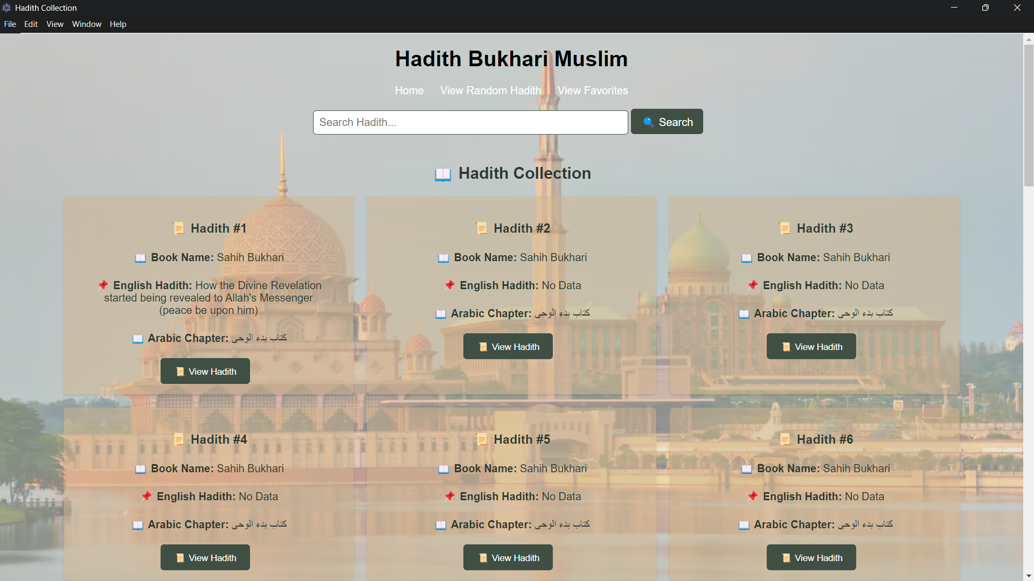

4.2 View Detail Hadith

This application display details of the hadiths.

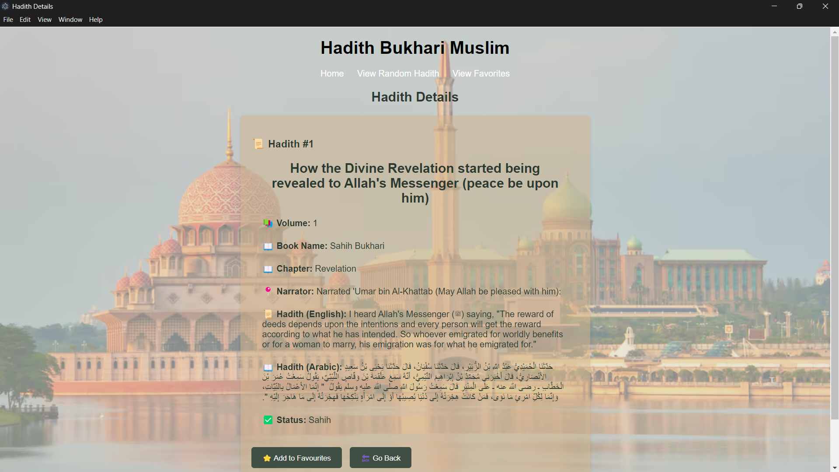

4.3 Random Hadith Display

* The application fetches 4 random Hadiths and displays them in a grid format (2 Hadiths per row).
* Each Hadith includes:
  1. Hadith Number
  2. Volume
  3. English Narrator
  4. Hadith Text (English & Arabic)
  5. Book Slug and Status

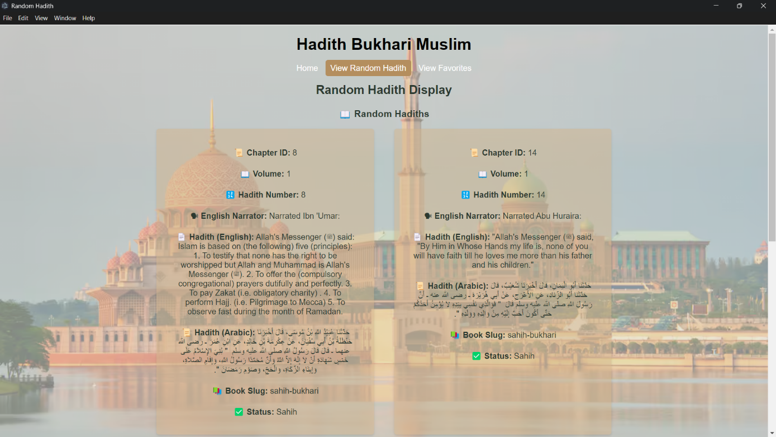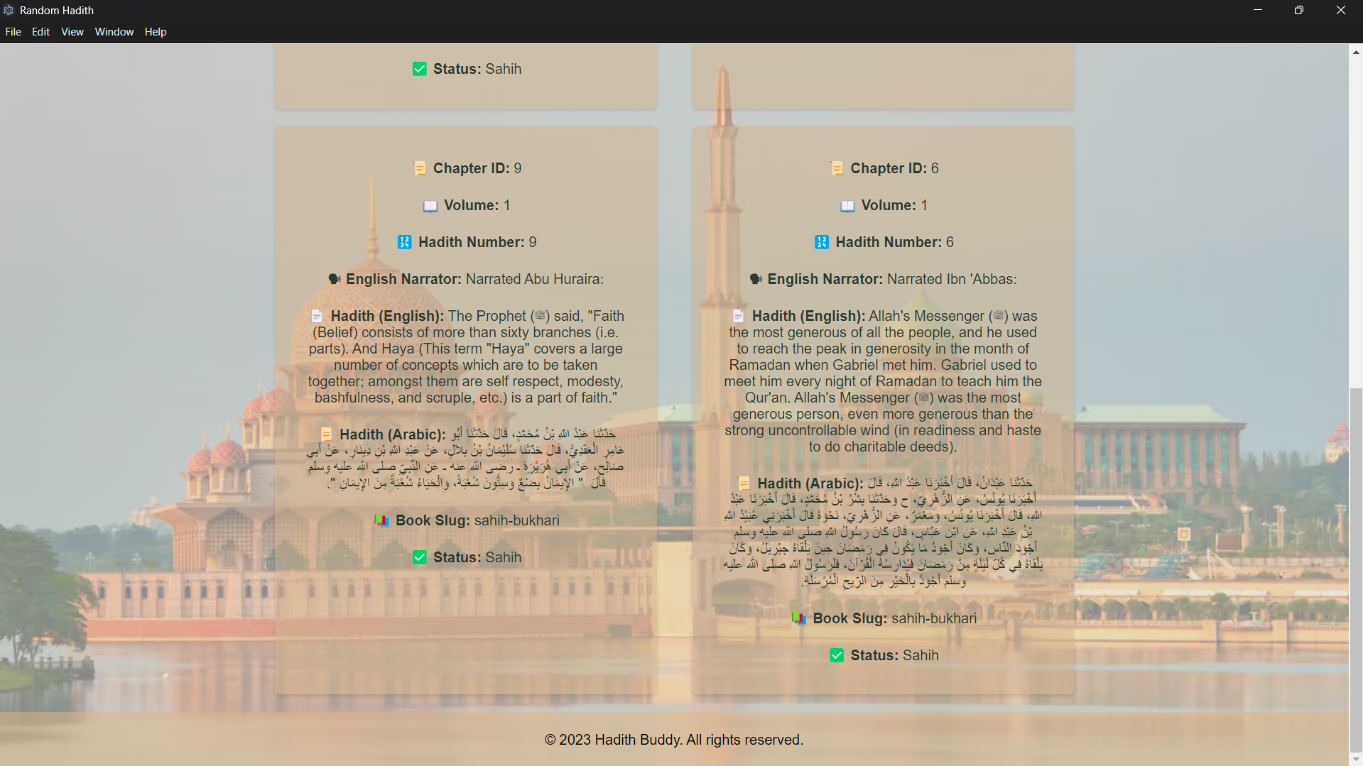

4.4 Favorite Hadith Management

* + Users can save Hadiths to favorites, which are stored using localStorage.
  + The favorite Hadiths are retrieved and displayed in a separate section.
  + Users can remove Hadiths from the list at any time.

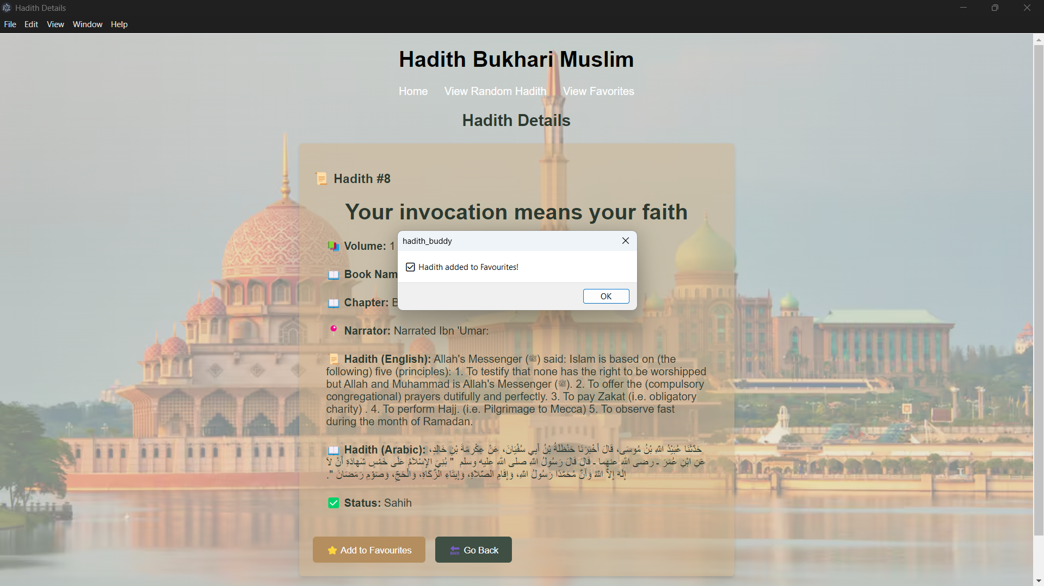 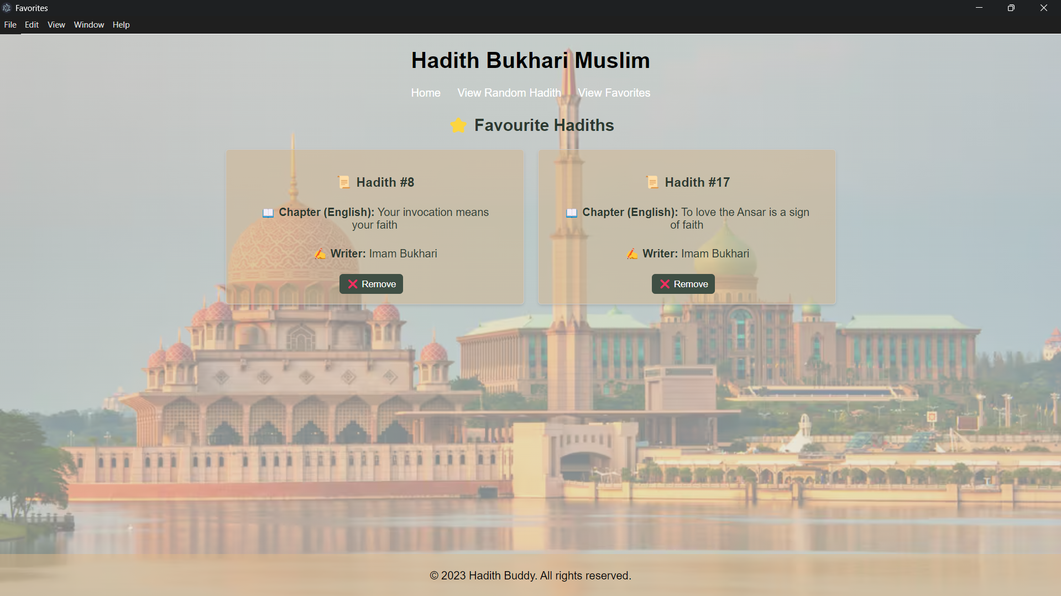 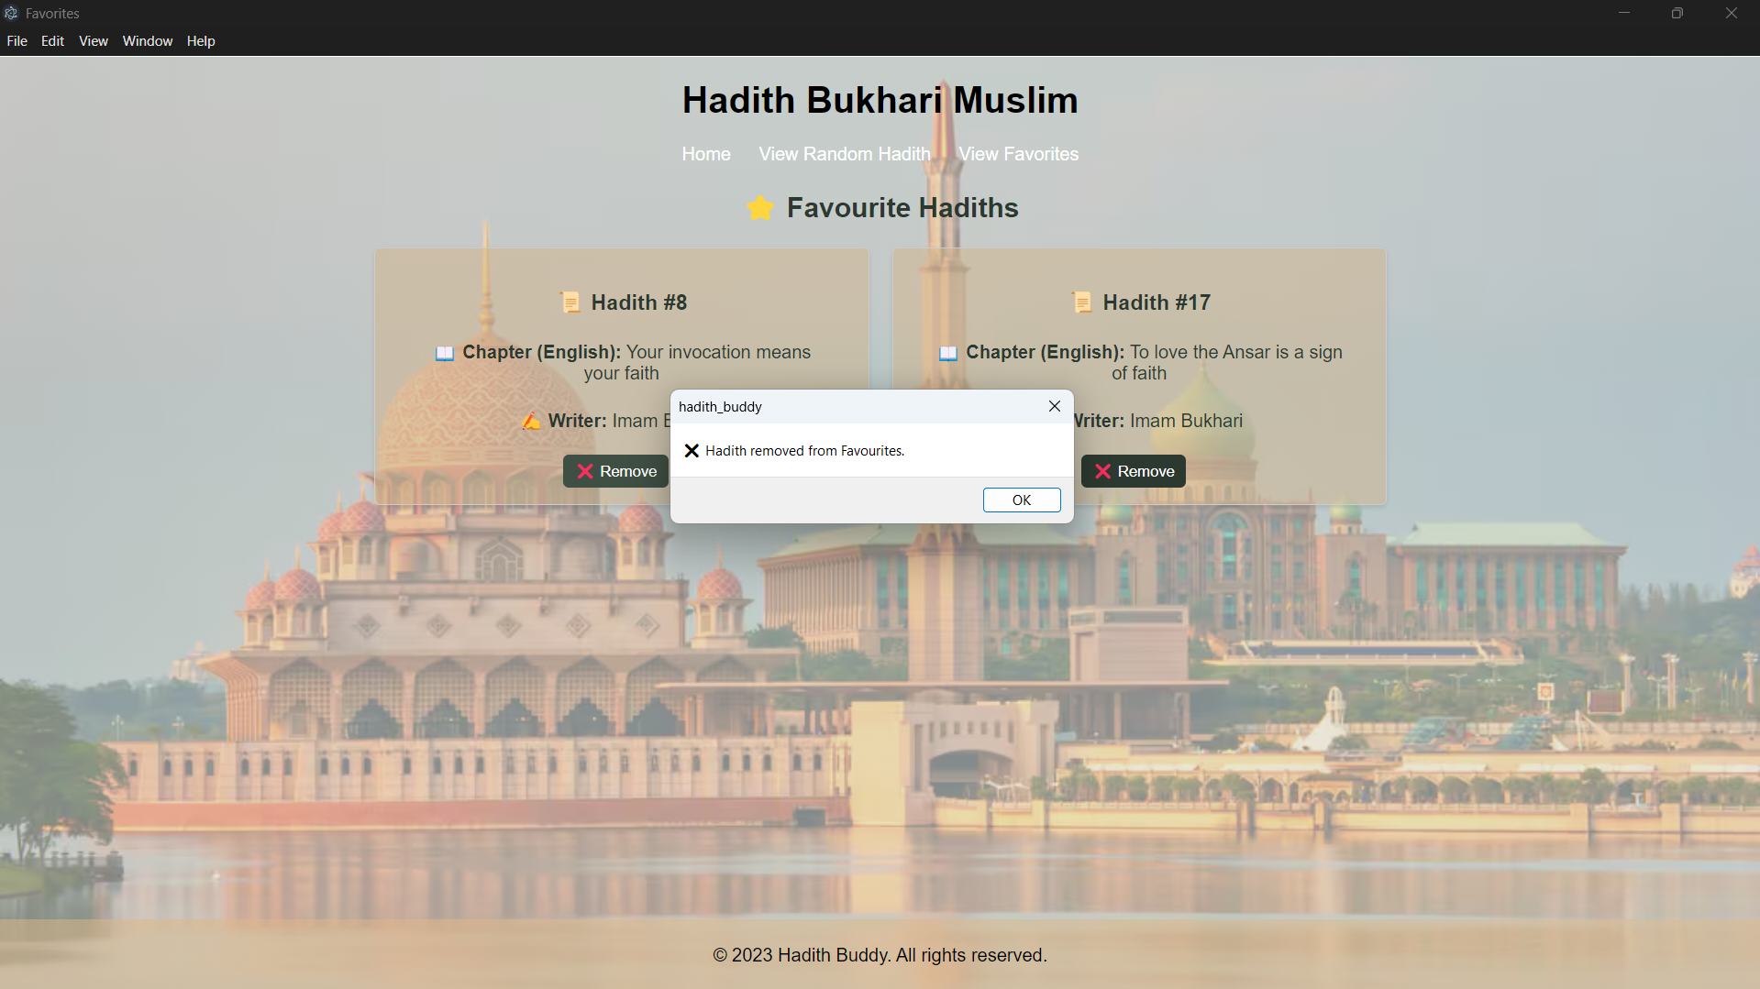

4.5 Search Button

User can search any topic or hadith that user want and it will display all hadith that got any keyword for text user been search.

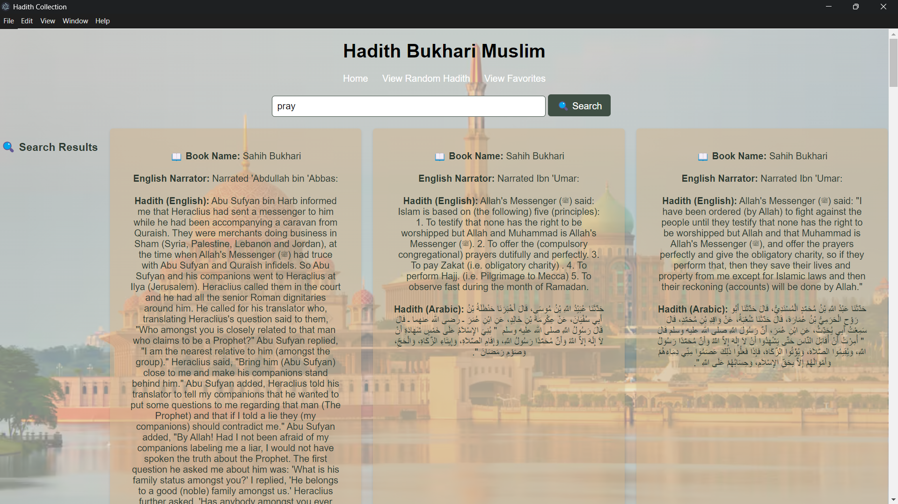

5.0 CODE OF THE PROGRAM

index.css

body {

font-family: Arial, sans-serif;

background: radial-gradient(circle, rgba(220,215,201,0.6), rgba(220,215,201,0.6)), url('masjid.avif') no-repeat center center fixed;

background-size: cover;

color: #2C3930;

display: flex;

flex-direction: column;

min-height: 100vh;

margin: 0; /* Remove default margin */

}

p, h1, h2 {

margin: 20px;

}

#hadith-container {

margin-bottom: 20px;

padding: 20px;

background: rgba(162,123,92,0.5);

border-radius: 5px;

color: #2C3930;

}

button {

margin-right: 10px;

background-color: #3F4F44;

color: white;

border: none;

padding: 10px 20px;

border-radius: 5px;

cursor: pointer;

text-decoration: none; /* Remove underline */

}

header{

color: black;

text-align: center;

}

footer {

background: rgba(222, 184, 135, 0.5); /* Adjusted background color */

color: black;

padding: 10px;

text-align: center;

margin-top: auto; /* Push footer to the bottom */

padding: 2px;

}

input, .hadith-button {

margin: 10px 0;

padding: 10px;

border-radius: 5px;

border: 1px solid #3F4F44;

}

.home-button, .hadith-random-button, .hadith-fav-button {

background: rgba(222, 184, 135, 0.5), rgba(180, 142, 94, 0.5);

color: white;

padding: 7px 10px;

border-radius: 5px;

text-decoration: none; /* Remove underline */

}

.home-button:hover, .hadith-random-button:hover, .hadith-fav-button:hover {

background-color: rgb(180, 142, 94);

}

ul {

list-style-type: none;

padding: 0;

}

li {

margin-bottom: 10px;

}

h1, h2 {

text-align: center;

}

#app {

max-width: 800px;

margin: 0 auto;

}

#chapters-list {

display: flex;

flex-wrap: wrap;

gap: 10px;

}

.chapter-item {

background: rgba(255, 255, 255, 0.8);

padding: 10px;

border-radius: 5px;

width: calc(33.333% - 10px);

box-sizing: border-box;

}

#favorites-list {

list-style-type: none;

padding: 0;

}

#favorites-list li {

padding: 10px;

border: 1px solid #ccc;

background-color: #fff;

margin-top: 10px;

}

/* ✅ Style container for 2-column layout */

.fav-hadith-container {

display: flex;

gap: 30px; /* Space between hadiths */

justify-content: center; /* Center hadiths */

}

/* ✅ Each Hadith item */

.hadith-item {

width: calc(50% - 30px); /* 2 items per row with gap consideration */

padding: 10px;

border: 1px solid #ccc;

border-radius: 5px;

background-color: #f9f9f9;

text-align: center;

box-shadow: 2px 2px 5px rgba(0, 0, 0, 0.2);

}

.hadith-item button {

background-color: #3F4F44;

color: white;

border: none;

padding: 5px 10px;

cursor: pointer;

}

.hadith-item button:hover {

background-color: #2C3930;

}

.modal {

display: none;

position: fixed;

z-index: 1;

left: 0;

top: 0;

width: 100%;

height: 100%;

overflow: auto;

background-color: rgb(0,0,0);

background-color: rgba(0,0,0,0.4);

}

.modal-content {

background-color: #fefefe;

margin: 15% auto;

padding: 20px;

border: 1px solid #888;

width: 80%;

}

.close {

color: #aaa;

float: right;

font-size: 28px;

font-weight: bold;

}

.close:hover,

.close:focus {

color: black;

text-decoration: none;

cursor: pointer;

}

/* ✅ Make search bar always visible */

.search-container {

padding: 10px;

text-align: center;

}

/* ✅ Style the search input and button */

.search-container input {

padding: 8px;

width: 30%;

font-size: 16px;

border-radius: 5px;

}

.search-container button {

padding: 8px 15px;

font-size: 16px;

background-color: #3F4F44;

border-radius: 5px;

cursor: pointer;

}

.search-container button:hover {

background-color: #2C3930;

}

#hadith-list, #fav-hadith-list {

display: flex;

flex-wrap: wrap;

gap: 20px;

justify-content: center;

}

.hadith-item {

flex: 1 1 calc(50% - 40px); /* Ensures 2 columns per row */

background: rgba(210, 180, 140, 0.5); /* Tan color with transparency */

padding: 15px;

border-radius: 5px;

box-shadow: 0 2px 4px rgba(0, 0, 0, 0.1);

text-align: center;

min-width: 300px; /* Ensure proper size */

max-width: 400px; /* Adjust width to maintain 2-per-row */

}

.hadith-detail-container {

background: rgba(210, 180, 140, 0.5);

padding: 20px;

border-radius: 5px;

box-shadow: 0 2px 4px rgba(0, 0, 0, 0.1);

max-width: 600px;

margin: 20px auto;

text-align: left;

}

.hadith-detail-container button {

background-color: #3F4F44;

color: white;

border: none;

padding: 10px 20px;

border-radius: 5px;

cursor: pointer;

text-decoration: none; /* Remove underline */

margin-top: 20px;

}

.hadith-detail-container button:hover {

background-color: rgb(180, 142, 94);

}

/* Centered Content */

#random-hadith-display {

text-align: center;

margin: 20px auto;

max-width: 900px;

}

/* Grid Layout for Hadiths (2 per row) */

.hadith-row {

display: flex;

justify-content: space-between;

gap: 15px;

margin-bottom: 20px;

}

/* Responsive Design */

@media (max-width: 768px) {

.hadith-row {

flex-direction: column;

}

.hadith-item {

width: 100%; /* Full width on small screens */

}

}

#search-results {

display: flex;

flex-wrap: wrap;

gap: 20px;

justify-content: center;

}

.search-result-item {

flex: 1 1 calc(50% - 40px); /* Ensures 2 columns per row */

background: rgba(210, 180, 140, 0.5); /* Tan color with transparency */

padding: 15px;

border-radius: 5px;

box-shadow: 0 2px 4px rgba(0, 0, 0, 0.1);

text-align: center;

min-width: 300px; /* Ensure proper size */

max-width: 400px; /* Adjust width to maintain 2-per-row */

}

Index.html

<!DOCTYPE html>

<html lang="en">

<head>

<meta charset="UTF-8">

<meta name="viewport" content="width=device-width, initial-scale=1.0">

<title>Hadith Collection</title>

<link rel="stylesheet" href="index.css">

</head>

<body>

<header>

<h1>Hadith Bukhari Muslim</h1>

<a href="index.html" class="home-button">Home</a>

<a href="hadith-random.html" class="hadith-random-button">View Random Hadith</a>

<a href="hadith-fav.html" class="hadith-fav-button">View Favorites</a>

</header>

<main>

<div class="search-container">

<input type="text" id="searchInput" placeholder="Search Hadith...">

<button onclick="searchHadith()">🔍 Search</button>

</div>

<!-- ✅ Display Area -->

<div id="search-results"></div>

<h2>📖 Hadith Collection</h2>

<div id="hadith-list"></div> <!-- Re-added the hadith list div -->

</main>

<footer>

<p>&copy; 2025 Hadith Buddy. All rights reserved.</p>

</footer>

<script src="hadith.js"></script>

</body>

</html>

Hadith-detail.html

<!DOCTYPE html>

<html lang="en">

<head>

<meta charset="UTF-8">

<meta name="viewport" content="width=device-width, initial-scale=1.0">

<title>Hadith Details</title>

<link rel="stylesheet" href="index.css">

</head>

<body>

<header>

<h1>Hadith Bukhari Muslim</h1>

<a href="index.html" class="home-button">Home</a>

<a href="hadith-random.html" class="hadith-random-button">View Random Hadith</a>

<a href="hadith-fav.html" class="hadith-fav-button">View Favorites</a>

</header>

<main>

<h2>Hadith Details</h2>

<div id="hadith-detail"></div>

<div id="hadith-detail-container" class="hadith-detail-container"></div>

<!--hadith details display here-->

</main>

<footer>

<p>&copy; 2025 Hadith Buddy. All rights reserved.</p>

</footer>

<script src="hadith-detail.js"></script>

</body>

</html>

Hadith-random.html

<!DOCTYPE html>

<html lang="en">

<head>

<meta charset="UTF-8">

<meta name="viewport" content="width=device-width, initial-scale=1.0">

<title>Random Hadith</title>

<link rel="stylesheet" href="index.css">

</head>

<body>

<header>

<h1>Hadith Bukhari Muslim</h1>

<a href="index.html" class="home-button">Home</a>

<a href="hadith-random.html" class="hadith-random-button">View Random Hadith</a>

<a href="hadith-fav.html" class="hadith-fav-button">View Favorites</a>

</header>

<main>

<h2>Random Hadith Display</h2>

<div id="random-hadith-display" class="random-hadith"></div>

</main>

<footer>

<p>&copy; 2023 Hadith Buddy. All rights reserved.</p>

</footer>

<script src="hadith-random.js"></script>

</body>

</html>

Hadith-fav.html

<!DOCTYPE html>

<html lang="en">

<head>

<meta charset="UTF-8">

<meta name="viewport" content="width=device-width, initial-scale=1.0">

<title>Favorites</title>

<link rel="stylesheet" href="index.css">

</head>

<body>

<header>

<h1>Hadith Bukhari Muslim</h1>

<a href="index.html" class="home-button">Home</a>

<a href="hadith-random.html" class="hadith-random-button">View Random Hadith</a>

<a href="hadith-fav.html" class="hadith-fav-button">View Favorites</a>

</header>

<main id="fav-hadith-container">

<h2>⭐ Favourite Hadiths</h2>

<div id="fav-hadith-list"></div> <!-- ✅ JavaScript will insert the hadiths here -->

</main>

<footer>

<p>&copy; 2023 Hadith Buddy. All rights reserved.</p>

</footer>

<div id="fav-hadith-list"></div>

<script src="hadith-fav.js"></script>

</body>

</html>

Hadith-list.html

<!DOCTYPE html>

<html lang="en">

<head>

<meta charset="UTF-8">

<meta name="viewport" content="width=device-width, initial-scale=1.0">

<title>List</title>

<link rel="stylesheet" href="index.css">

</head>

<body>

<header>

<h1>Hadith Bukhari Muslim</h1>

<a href="index.html" class="home-button">Home</a>

<a href="hadith-random.html" class="hadith-random-button">View Random Hadith</a>

<a href="hadith-fav.html" class="hadith-fav-button">View Favorites</a>

</header>

<main>

<h2>⭐ Favourite Hadiths</h2>

<div id="fav-hadith-list" class="hadith-list"></div>

</main>

<footer>

<p>&copy; 2023 Hadith Buddy. All rights reserved.</p>

</footer>

<div id="fav-hadith-list" class="hadith-list"></div>

<script src="hadith-list.js"></script>

</body>

</html>

hadith.js

const API_KEY = "$2y$10$imRVx8ZhnDdBGcKCABQ95ePS8VhQ6gFzUnWyIbR4xeYsGFDrGcnvC";

const API_URL = `https://hadithapi.com/api/hadiths?apiKey=${API_KEY}`;

let allHadiths = []; // ✅ Declare globally

async function fetchHadiths() {

try {

const response = await fetch(API_URL, {

method: "GET",

headers: { "Content-Type": "application/json" }

});

if (!response.ok) {

throw new Error(`API Error: ${response.status}`);

}

const data = await response.json();

console.log("📌 Full API Response:", data); // Debugging

// ✅ Store hadiths globally

allHadiths = data.hadiths?.data || [];

if (!Array.isArray(allHadiths) || allHadiths.length === 0) {

throw new Error("❌ No hadiths found in the API response.");

}

displayHadiths(allHadiths); // ✅ Display all hadiths on page load

} catch (error) {

console.error("❌ Fetch error:", error.message);

document.getElementById("hadith-list").innerHTML = `<p>Error loading Hadiths. Please try again.</p>`;

}

}

// ✅ Display Hadiths

function displayHadiths(hadiths) {

let container = document.getElementById("hadith-list");

container.innerHTML = ""; // Clear previous content

hadiths.forEach(hadith => {

let div = document.createElement("div");

div.className = "hadith-item";

div.innerHTML = `

<h3>📜 Hadith #${hadith.id}</h3>

<p><strong>📖 Book Name:</strong> ${hadith.book?.bookName || "Unknown"}</p>

<p><strong>📌 English Hadith:</strong> ${hadith.headingEnglish || "No Data"}</p>

<p><strong>📖 Arabic Chapter:</strong> ${hadith.chapter?.chapterArabic || "No Data"}</p>

<button onclick="viewHadith(${hadith.id})">📜 View Hadith</button>

`;

container.appendChild(div);

});

}

// ✅ View Hadith Details

function viewHadith(hadithId) {

window.location.href = `hadith-detail.html?id=${hadithId}`;

}

// ✅ Load Hadiths on Page Load

document.addEventListener("DOMContentLoaded", fetchHadiths);

// ✅ Search Function

function searchHadith() {

let query = document.getElementById("searchInput").value.toLowerCase();

if (allHadiths.length === 0) {

console.warn("❌ Hadith data is not loaded yet.");

return;

}

let results = allHadiths.filter(hadith =>

(hadith.hadithEnglish && hadith.hadithEnglish.toLowerCase().includes(query)) ||

(hadith.hadithArabic && hadith.hadithArabic.toLowerCase().includes(query)) ||

(hadith.englishNarrator && hadith.englishNarrator.toLowerCase().includes(query))

);

displaySearchResults(results);

}

// ✅ Display Search Results

function displaySearchResults(hadiths) {

const resultsDiv = document.getElementById("search-results");

resultsDiv.innerHTML = `<h3>🔍 Search Results</h3>`;

if (hadiths.length === 0) {

resultsDiv.innerHTML += `<p>No Hadiths found for your search.</p>`;

return;

}

hadiths.forEach(hadith => {

const hadithItem = document.createElement("div");

hadithItem.className = "search-result-item"; // Apply new CSS class

hadithItem.innerHTML = `

<p><strong>📖 Book Name:</strong> ${hadith.book?.bookName || "Unknown"}</p>

<p><strong>English Narrator:</strong> ${hadith.englishNarrator || "Unknown"}</p>

<p><strong>Hadith (English):</strong> ${hadith.hadithEnglish || "No Data"}</p>

<p><strong>Hadith (Arabic):</strong> ${hadith.hadithArabic || "No Data"}</p>

`;

resultsDiv.appendChild(hadithItem);

});

}

Hadith-detail.js

const API_KEY = "$2y$10$imRVx8ZhnDdBGcKCABQ95ePS8VhQ6gFzUnWyIbR4xeYsGFDrGcnvC";

const API_URL = `https://hadithapi.com/api/hadiths?apiKey=${API_KEY}`;

// ✅ Fetch a Single Hadith by ID

async function fetchHadithDetail() {

const urlParams = new URLSearchParams(window.location.search);

const hadithId = urlParams.get("id");

if (!hadithId) {

document.getElementById("hadith-detail-container").innerHTML = `<p>⚠️ Invalid Hadith ID.</p>`;

return;

}

try {

const response = await fetch(`${API_URL}&id=${hadithId}`);

if (!response.ok) {

throw new Error(`API Error: ${response.status}`);

}

const data = await response.json();

console.log("📌 Hadith Detail API Response:", data);

const hadith = data.hadiths?.data?.find(h => h.id == hadithId);

if (!hadith) {

throw new Error("❌ Hadith not found.");

}

displayHadithDetail(hadith);

} catch (error) {

console.error("❌ Fetch error:", error.message);

document.getElementById("hadith-detail-container").innerHTML = `<p>⚠️ Error loading Hadith.</p>`;

}

}

// ✅ Display the Hadith Detail

function displayHadithDetail(hadith) {

let container = document.getElementById("hadith-detail-container");

container.innerHTML = `

<div class="hadith-detail-box">

<h3>📜 Hadith #${hadith.hadithNumber || hadith.id}</h2>

<h1>${hadith.headingEnglish}</h1>

<p><strong>📚 Volume:</strong> ${hadith.volume || "Unknown"}</p>

<p><strong>📖 Book Name:</strong> ${hadith.book?.bookName || "Unknown"}</p>

<p><strong>📖 Chapter:</strong> ${hadith.chapter?.chapterEnglish || "N/A"}</p>

<p><strong>📍 Narrator:</strong> ${hadith.englishNarrator || "Unknown"}</p>

<p><strong>📜 Hadith (English):</strong> ${hadith.hadithEnglish}</p>

<p><strong>📖 Hadith (Arabic):</strong> ${hadith.hadithArabic || "N/A"}</p>

<p><strong>✅ Status:</strong> ${hadith.status || "Unknown"}</p>

<div class="buttons">

<button onclick="addToFavourites(${hadith.id})">⭐ Add to Favourites</button>

<button onclick="window.history.back()">🔙 Go Back</button>

</div>

</div>

`;

}

// ✅ Function to Add Hadith to Favourites

function addToFavourites(hadithId) {

let favourites = JSON.parse(localStorage.getItem("favouriteHadiths")) || [];

if (!favourites.includes(hadithId)) {

favourites.push(hadithId);

localStorage.setItem("favouriteHadiths", JSON.stringify(favourites));

alert("✅ Hadith added to Favourites!");

} else {

alert("⚠️ Hadith already in Favourites.");

}

}

// ✅ Load Hadith Detail on Page Load

document.addEventListener("DOMContentLoaded", fetchHadithDetail);

hadith-random.js

const API_KEY = "$2y$10$imRVx8ZhnDdBGcKCABQ95ePS8VhQ6gFzUnWyIbR4xeYsGFDrGcnvC";

const hadithApiUrl = `https://hadithapi.com/api/hadiths?apiKey=${API_KEY}`;

async function fetchRandomHadiths() {

try {

const response = await fetch(hadithApiUrl, {

method: "GET",

headers: {

"Authorization": `Bearer ${API_KEY}`,

"Content-Type": "application/json"

}

});

if (!response.ok) {

throw new Error(`API Error: ${response.status} - ${response.statusText}`);

}

const data = await response.json();

console.log("Full API Response:", data); // Debugging

console.log("Hadiths Object:", data.hadiths); // Debugging

// Extract hadiths from `data.hadiths.data`

const hadiths = data.hadiths?.data || [];

if (!Array.isArray(hadiths) || hadiths.length === 0) {

throw new Error("No Hadiths found in the API response.");

}

const randomHadiths = getRandomHadiths(hadiths, 4);

displayRandomHadiths(randomHadiths);

} catch (error) {

console.error("Fetch error:", error.message);

document.getElementById("random-hadith-display").innerHTML = `

<p style="color: red;">Error fetching Hadiths: ${error.message}</p>`;

}

}

// ✅ Get 4 random Hadiths

function getRandomHadiths(hadiths, count) {

if (!Array.isArray(hadiths)) return [];

return hadiths.sort(() => 0.5 - Math.random()).slice(0, count);

}

// ✅ Display Hadiths in 2 Columns (2 per row)

function displayRandomHadiths(hadiths) {

const randomHadithDisplay = document.getElementById("random-hadith-display");

randomHadithDisplay.innerHTML = "<h3>📖 Random Hadiths</h3>";

let row;

hadiths.forEach((hadith, index) => {

if (index % 2 === 0) {

row = document.createElement("div");

row.className = "hadith-row";

randomHadithDisplay.appendChild(row);

}

const hadithItem = document.createElement("div");

hadithItem.className = "hadith-item";

hadithItem.innerHTML = `

<p><strong>📜 Chapter ID:</strong> ${hadith.id}</p>

<p><strong>📖 Volume:</strong> ${hadith.volume}</p>

<p><strong>🔢 Hadith Number:</strong> ${hadith.hadithNumber}</p>

<p><strong>🗣 English Narrator:</strong> ${hadith.englishNarrator}</p>

<p><strong>📄 Hadith (English):</strong> ${hadith.hadithEnglish}</p>

<p><strong>📜 Hadith (Arabic):</strong> ${hadith.hadithArabic}</p>

<p><strong>📚 Book Slug:</strong> ${hadith.bookSlug}</p>

<p><strong>✅ Status:</strong> ${hadith.status}</p>

`;

row.appendChild(hadithItem);

});

}

document.addEventListener("DOMContentLoaded", () => {

fetchRandomHadiths();

});

Hadith-fav.js

const API_KEY = "$2y$10$imRVx8ZhnDdBGcKCABQ95ePS8VhQ6gFzUnWyIbR4xeYsGFDrGcnvC";

const API_URL = "https://hadithapi.com/api/hadiths";

// ✅ Load Favourite Hadiths

async function loadFavourites() {

let favourites = JSON.parse(localStorage.getItem("favouriteHadiths")) || [];

if (favourites.length === 0) {

document.getElementById("fav-hadith-list").innerHTML = `<p>⚠️ No Favourite Hadiths Yet.</p>`;

return;

}

let container = document.getElementById("fav-hadith-list");

container.innerHTML = ""; // Clear previous content

for (let hadithId of favourites) {

try {

// ✅ FIX: Correct API call

const response = await fetch(`${API_URL}?apiKey=${API_KEY}&id=${hadithId}`);

if (!response.ok) {

throw new Error(`API Error: ${response.status}`);

}

const data = await response.json();

console.log("📌 Favourite Hadith:", data); // Debugging

const hadith = data.hadiths?.data?.find(h => h.id == hadithId); // ✅ FIX: Proper extraction

if (!hadith) {

console.warn(`⚠️ Hadith ID ${hadithId} not found.`);

continue; // Skip to the next one

}

let div = document.createElement("div");

div.className = "hadith-item";

div.innerHTML = `

<h3>📜 Hadith #${hadith.hadithNumber || hadith.id}</h3>

<p><strong>📖 Chapter (English):</strong> ${hadith.headingEnglish || "No Data"}</p>

<p><strong>✍️ Writer:</strong> ${hadith.book?.writerName || "Unknown"}</p>

<button onclick="removeFromFavourites(${hadith.id})">❌ Remove</button>

`;

container.appendChild(div);

} catch (error) {

console.error("❌ Fetch error:", error.message);

}

}

}

// ✅ Remove Hadith from Favourites

function removeFromFavourites(hadithId) {

let favourites = JSON.parse(localStorage.getItem("favouriteHadiths")) || [];

favourites = favourites.filter(id => id !== hadithId);

localStorage.setItem("favouriteHadiths", JSON.stringify(favourites));

alert("❌ Hadith removed from Favourites.");

loadFavourites(); // Refresh list

}

// ✅ Load Favourites on Page Load

document.addEventListener("DOMContentLoaded", loadFavourites);

hadith-list.js

const API_KEY = "$2y$10$imRVx8ZhnDdBGcKCABQ95ePS8VhQ6gFzUnWyIbR4xeYsGFDrGcnvC";

const HADITHS_API_URL = `https://hadithapi.com/api/hadiths?apiKey=${API_KEY}`;

async function fetchHadiths() {

const urlParams = new URLSearchParams(window.location.search);

const chapterId = urlParams.get("chapter");

if (!chapterId) {

document.getElementById("hadith-list").innerHTML = `<p>⚠️ Invalid Chapter ID.</p>`;

return;

}

try {

const response = await fetch(`${HADITHS_API_URL}&chapter=${chapterId}`);

if (!response.ok) throw new Error(`API Error: ${response.status}`);

const data = await response.json();

console.log("📌 Hadiths in Chapter:", data);

const hadiths = data.hadiths?.data || [];

if (!Array.isArray(hadiths) || hadiths.length === 0) {

throw new Error("❌ No hadiths found.");

}

displayHadiths(hadiths);

} catch (error) {

console.error("❌ Fetch error:", error.message);

document.getElementById("hadith-list").innerHTML = `<p>Error loading Hadiths. Please try again.</p>`;

}

}

function displayHadiths(hadiths) {

let container = document.getElementById("hadith-list");

container.innerHTML = "";

hadiths.forEach(hadith => {

let div = document.createElement("div");

div.className = "hadith-item";

div.innerHTML = `

<h3>📜 Hadith #${hadith.id}</h3>

<p><strong>📘 Book Name:</strong> ${hadith.book?.bookName || "Unknown"}</p>

<p><strong>📍 Chapter:</strong> ${hadith.chapter?.chapterEnglish || "No Data"}</p>

<p><strong>📝 Hadith:</strong> ${hadith.hadithEnglish}</p>

<button onclick="viewHadithDetail(${hadith.id})">📜 View Detail</button>

`;

container.appendChild(div);

});

}

// ✅ Function to redirect to hadith-detail.html with Hadith ID

function viewHadithDetail(hadithId) {

window.location.href = `hadith-detail.html?id=${hadithId}`;

}

// ✅ Load Hadiths when page loads

document.addEventListener("DOMContentLoaded", fetchHadiths);

6. Future Enhancements

Search and Filter Functionality – Allow users to search Hadiths by topic or narrator.

User Authentication – Implement user login to save favorites in a database instead of local storage.

Multilingual Support – Add translations for Hadiths in different languages.

7. Conclusion

The Hadith application successfully meets its objectives by providing an interactive and user-friendly platform to browse, view, and manage Hadiths. The API integration, local storage management, and responsive design make it a functional and efficient web-based tool. Future enhancements could further improve user experience and engagement.